HANDS-ON : 1

OUPUT:-

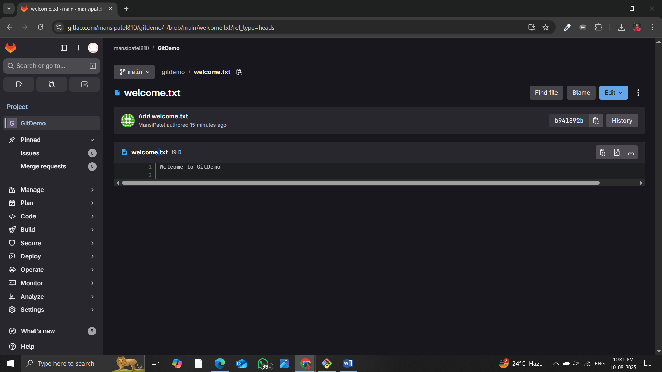

Below are the steps followed:-

**Step 1: Setup your machine with Git Configuration**

To check if Git client is installed properly

To configure user level configuration of user ID and email ID execute

**Step 2: Integrate notepad++.exe to Git and make it a default editor**

Notepad++ will show the entire global configuration

**Step 3: Add a file to source code repository**

1. Open Git bash shell and create a new project “GitDemo” by executing the command
2. Git bash initializes the “**GitDemo**” repository. To verify, execute the command
3. To create a file **“welcome.txt”** and add content to the file, execute the command
4. Check the status , Now the file **“welcome.txt”** is available in Git “working directory”
5. To make the file to be tracked by Git repository, execute the command
6. To add multi line comments, we are opening default editor to comment. Execute the command
7. To check if local and “Working Directory” git repository are same, execute git status

**welcome.txt** is added to the local repository.

1. Signup with GitLab and create a remote repository **“GitDemo”**
2. To pull the remote repository, execute git pull origin master
3. To push the local to remote repository, execute git push origin master

